Hands On Session
Spring REST - Country Web Service

This is a Spring Boot REST service that returns India country details.
## Project Structure
```
src/main/java/com/cognizant/springlearn/
├── SpringLearnApplication.java # Main Spring Boot application
├── controller/
│ └── CountryController.java # REST controller with /country endpoint
└── model/
└── Country.java # Country model class

src/main/resources/
├── applicationContext.xml # Spring XML configuration with India bean
└── application.properties # Application configuration
```
## Requirements
- Java 11 or higher
- Maven 3.6 or higher
## How to Run
1. **Build the project:**
```bash
mvn clean package
```
2. **Run the application:**
```bash
mvn spring-boot:run
```
3. **Access the service:**
- URL: http://localhost:8083/country
- Method: GET

## Expected Response
```json
{
"code": "IN",
"name": "India"
}
```
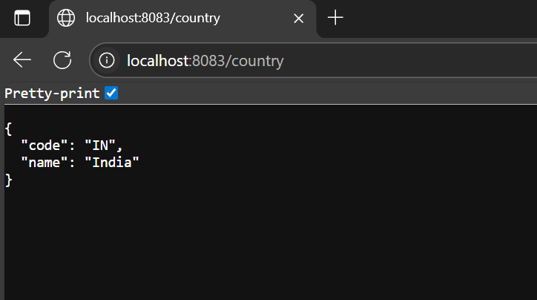
## Testing with Postman
1. Open Postman
2. Create a new GET request
3. Enter URL: `http://localhost:8083/country`
4. Click "Send"
5. View the response in the "Body" tab
6. Click on the "Headers" tab to view HTTP header details
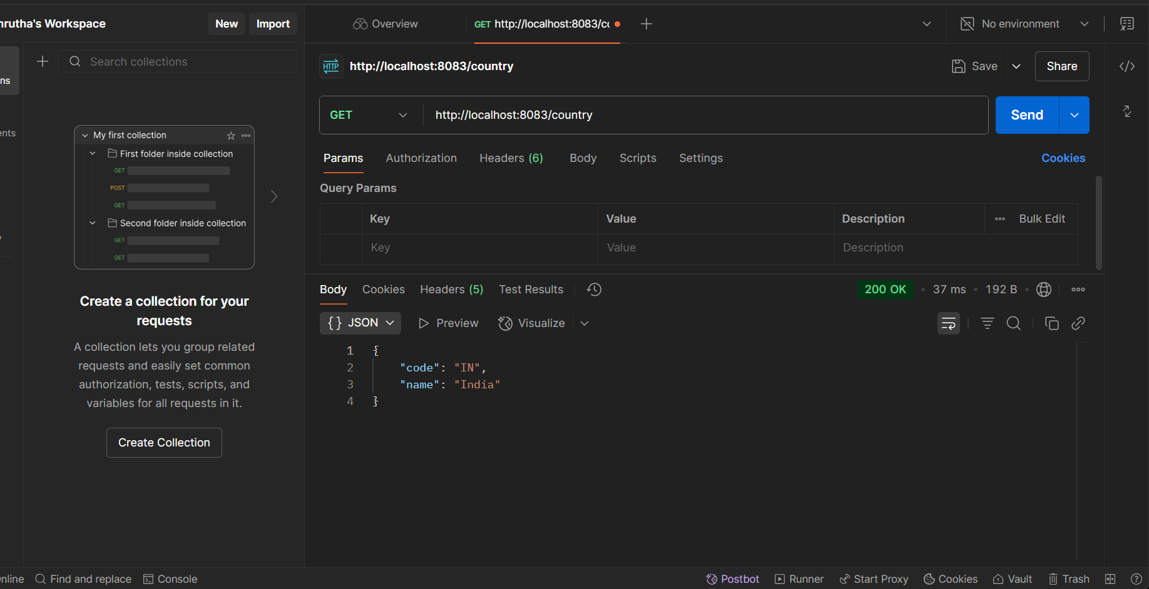

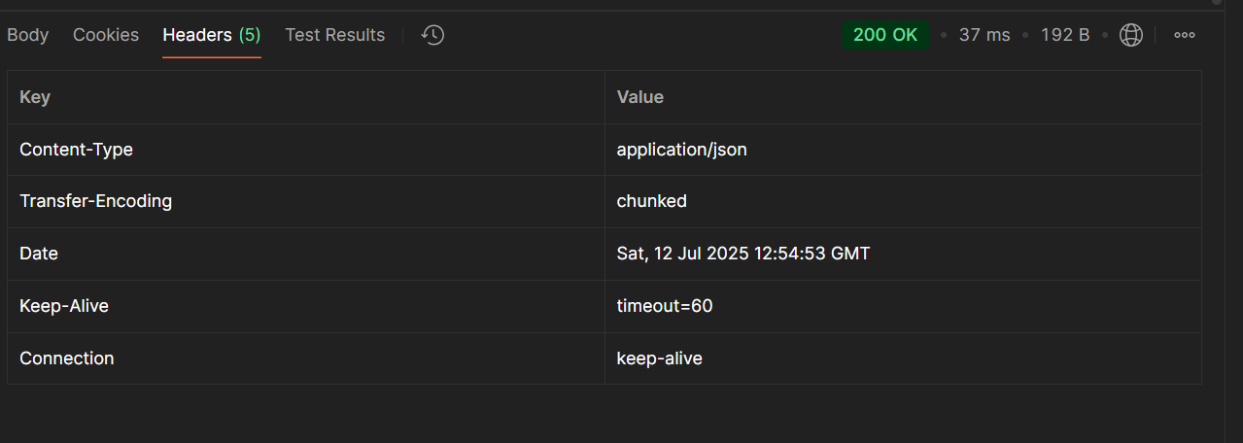

## Testing with Browser Developer Tools
1. Open browser and navigate to: `http://localhost:8083/country`
2. Open Developer Tools (F12)
3. Go to the "Network" tab
4. Refresh the page
5. Click on the request to view HTTP header details

## Technical Details
### Controller Method Explanation
The `getCountryIndia()` method in `CountryController`:
- Uses `@RequestMapping("/country")` to map to the `/country` URL
- Injects `ApplicationContext` to access Spring beans
- Retrieves the "india" bean from the XML configuration
- Returns the Country object, which is automatically converted to JSON

### JSON Conversion
Spring Boot automatically converts the returned `Country` object to JSON using:
- Jackson library (included in spring-boot-starter-web)
- Object properties are serialized to JSON key-value pairs
- The `@RestController` annotation enables automatic JSON conversion

### HTTP Headers
When testing, you'll see headers like:
- `Content-Type: application/json`
- `Content-Length: [size]`
- `Date: [timestamp]`
- `Server: [server info]`

